Our brainwave study, explained simply
A plain-language note on the BEED paper (Version 2): what we did, what we found and why it matters. Written so it can be retold to friends, family or visitors at a poster.

What is this about?
Many researchers teach computers to recognise seizures from brainwave recordings. A newer, free-to-download collection of recordings called BEED quickly became popular, and several groups reported that their programs got 95 to 99 out of 100 right on it.
We asked a simple question: are those programs learning about seizures, or about how the file was put together? The short answer: mostly about how the file was put together.

What is EEG and what is epilepsy?
- Epilepsy is a condition in which the brain sometimes has seizures: sudden bursts of unusual electrical activity that can cause shaking, staring or loss of awareness.
- EEG is a test that records the brain’s tiny electrical signals with small sensors on the head. The result is a set of wavy lines, one per sensor.
- Why it matters: doctors read these lines by eye, which is slow and needs an expert. Telling seizure types apart also matters, because it guides treatment.

What data did we use?
BEED (the Bangalore EEG Epilepsy Dataset) is one table of numbers with 8,000 rows of 16 numbers each. Each row is labelled as one of four groups, 2,000 rows per group:
- Healthy people.
- Generalised seizures: seizures that involve the whole brain.
- Focal seizures: seizures that start in one part of the brain.
- Seizure events: episodes that come with behaviours such as blinking or staring.
The file does not say which row came from which person, and its written description does not match what is actually in the file.

What we found inside the file
Finding 1: the healthy rows are identical to pieces of an older collection.
Every one of the 2,000 “healthy” rows is identical, number for number, to a short piece of an older, well-known public collection called the Bonn data (healthy volunteers with their eyes closed). The pieces come from 100 Bonn recordings, from one sensor, recorded at another centre at about 174 readings per second. None of the seizure rows matched the Bonn data. So the healthy group appears to come from a different source from the seizure groups.
Finding 2: a row means something different in each group.
A healthy row is 16 readings in a row from one sensor, like 16 frames from one camera (about a tenth of a second). A seizure row is a single moment seen by 16 sensors at once, like one frame from 16 cameras. A computer can therefore tell “healthy” from “seizure” just by the shape of the rows, without learning anything about brains.
Finding 3: neighbouring seizure rows are almost twins.
Seizure rows are moments about 4 thousandths of a second apart, taken one after another, so each row looks almost exactly like the next. Each seizure group seems to be one stretch of recording (or a few joined seamlessly) only about 8 seconds long in total.
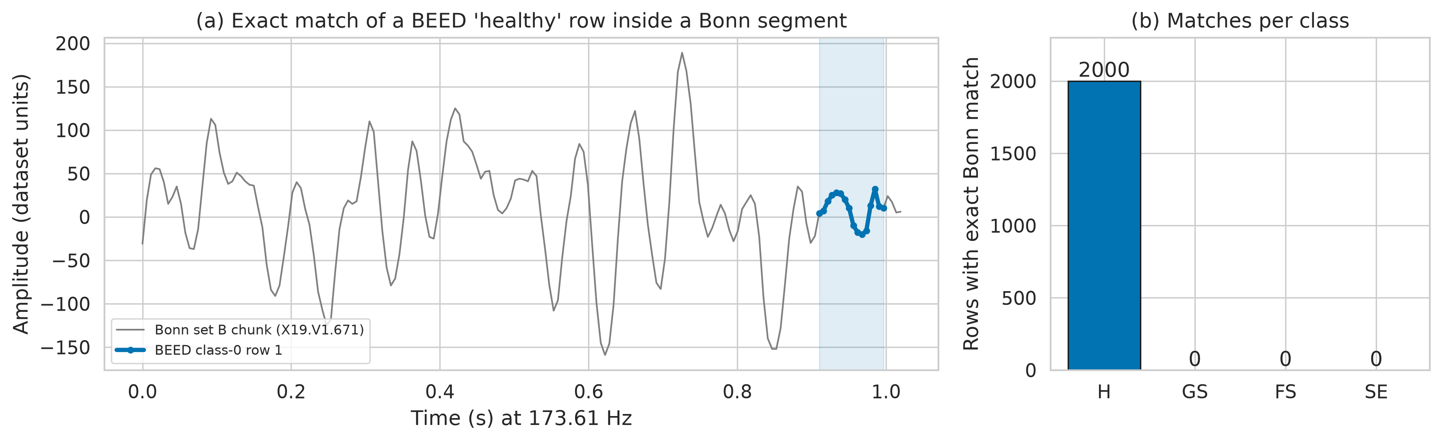
Picture. Left: the grey line is one second of brainwave from the older Bonn data; the blue dots are a “healthy” row from BEED and sit exactly on the grey line. Right: rows in each BEED group with an identical match in the Bonn data: all 2,000 healthy rows (H) and none of the generalised (GS), focal (FS) or seizure-event (SE) rows.

How we tested the programs
We tried ten kinds of programs that learn from examples (called “models”), from simple to more modern ones. Testing a model is like a school exam: it practises on some rows and is tested on rows it has not seen. Scores below are out of 100, using a score that treats every group equally (100 is perfect).
Most earlier studies shuffled the rows and picked the exam rows at random. Because neighbouring seizure rows are near-twins, almost every exam row had its twin in the practice set: for 88 to 95 out of every 100 seizure exam rows, the closest practice row was literally its next-door neighbour. It is like seeing near-copies of the exam questions the night before.
So we also tested fairly. We cut each seizure recording into five parts in time and tested each part once, practising on the rest and throwing away a small gap of rows on each side so no near-twins could cross over. Healthy rows were kept together by the Bonn recording they came from. We also chose our main model in advance, using only practice data, so we could not pick whichever model happened to do best in the exam.

What happened when we tested fairly
Way of testing | All four groups | Three seizure types
Rows shuffled (how most earlier studies tested) | 98 | 98
Fair test, main model chosen in advance | 75 (give or take 8) | 68 (give or take 10)
Recording “fingerprint” only (Finding 5) | 72 | 65
Pure guessing | 25 | 33
Table. Average scores out of 100. “Give or take” shows how much the fair score moved depending on which part of the recordings was tested.
Finding 4: fair testing removes most of the impressive score.
With shuffled rows the best model scored about 98 out of 100. Tested fairly, our main model scored about 75 for all four groups and about 68 for the three seizure types. Depending on which part of the recordings was tested, the four-group score ranged from about 63 to 84. Which model looked “best” also changed, and the top models could not be told apart. Picking whichever model did best on one lucky exam would have given 84 and 78, which is too optimistic, so we do not use those as our result.
Healthy versus seizure stayed almost perfect either way. But one simple check of how smooth a row looks got 997 out of 1,000 right on its own, which shows the computer is spotting where the rows came from, not a sign of illness.
Finding 5: much of the fair score is a recording “fingerprint”.
Because each seizure type seems to come from one recording, a model can win by recognising the recording rather than the seizure type, much as you might recognise a song from its loudness pattern without hearing the words. To test this we gave a model only the size of each sensor’s reading, ignoring whether it was up or down (its “loudness”). This fingerprint alone scored about 72 for four groups and 65 for three, about nine-tenths of what the main model achieves above guessing. So the fair score mostly measures “can it recognise a later moment of the same recording?”, not “can it tell seizure types apart in a new patient?”.
Finding 6: short stretches of signal help, but it is a different test.
When we gave the computer short stretches of signal (an eighth to a quarter of a second) instead of single moments, the seizure types were easier to tell apart: about 97 out of 100 on the final exam and about 92 (give or take 10) on average across repeated fair tests, against about 77 and 67 for single moments. Part of this gain comes simply from averaging over many moments, and the final exam had only 36 stretches, all from the same three recordings, so this cannot be compared with the scores above and says nothing about new patients.
In fair testing the models were also more sure of themselves than they should have been, so their confidence would need correcting before any real use.

What the study does NOT show
- It does not show that any one model is the best. Under fair testing the top models are effectively tied.
- It does not show that seizures or seizure types can be recognised in new patients. The file cannot test that.
- It does not support medical claims about healthy people, because the healthy group comes from a different source.
- It makes no claim that such a model could run on a wearable or other small device; we did not test any.
- We do not propose a new model.

Limitations
- The file does not say which person each row came from, so our fair test only checks later moments of the same recordings.
- Our conclusions about how the seizure rows are laid out come from patterns in the numbers, not from official documentation, and we could not find where the seizure rows originally came from.
- We chose the main model’s selection rule after an early look at the data; repeating the whole choice inside the fair test gave almost the same scores, which limits but does not remove this concern.
- We kept our models small and did not spend a long time fine-tuning them.

Why does it matter?
Scores of 95 to 99 out of 100 on this file mostly reflect how it was tested and assembled. Future studies should keep stretches of time apart when testing, choose their model before looking at the exam, report how much scores vary, and not use the healthy group for medical claims. Better data, with longer recordings and patient labels, would help most. All our code is shared, and rerunning it reproduces every number.

One-minute summary to say out loud
“Doctors use EEG, which records the brain’s electrical signals, to diagnose epilepsy. A popular public file called BEED has been used to teach computers to recognise seizures, with reported scores of up to 99 out of 100. We looked closely and found three things. First, all the ‘healthy’ examples are identical to pieces of an older collection recorded in a different way, so a computer can spot them by their shape alone. Second, the seizure examples are moments taken one after another, so shuffling them for testing is like seeing the exam answers in advance. Tested fairly, with the model chosen in advance, the score dropped from about 98 to about 75 out of 100, and for telling seizure types apart to about 68. Third, most of that remaining score can be matched just by recognising each recording’s ‘fingerprint’. Our message: test fairly, and be careful with this file.”

Quick Q&A
Q: So did the earlier studies get it wrong?
A: Their numbers match ours when we test the way they did. The issue is the testing method: shuffled rows let near-copies leak from practice into the exam.
Q: Is 75 out of 100 a bad result?
A: It is the honest figure for this file, and even it is flattering, because much of it comes from recognising the recording rather than the seizure type.
Q: Why not report your best single exam score?
A: Picking the best model on one exam that happened to be easy would have given 84 and 78. That is optimistic, so our main result is the model chosen in advance and tested on every part of the recordings.
Q: How did you know the healthy rows came from the Bonn data?
A: We searched the Bonn data for exact matches. All 2,000 healthy rows were found there, number for number. None of the seizure rows were.
Q: Can this be used in a hospital?
A: No. It could not be tested on new patients, and the healthy group comes from a different source. It is a study about testing methods, not a medical tool.
Q: What would make the data better?
A: Longer recordings that say which patient they came from, more than one recording per seizure type, and healthy examples recorded in the same way as the seizure ones.

